Kevin Butryn

Due Date: October 4, 2017

Class CS 388

1. Java Applet vs Java Program vs Java Script vs Angular Java Script.

Java Applet is a application that runs on the client's browser

Java Programs must be run on local machine whereas applet needs no explicit installation on local machine

JavaScript is a scripting language that typically runs in the browser and makes web pages dynamic and interactive.

AngularJS is a JavaScript framework and binds data to HTML with Expressions.

Companies will use JavaScript with AngularJS because now everything is on the internet. Which means a lot of applications will be run in browser and need to be implemented in html.

2.Eclipse IDE: Download eclipse installer from eclipse website. Double click and install eclipse. Create new Java project with main method. Write code and press green arrow to compile and run.

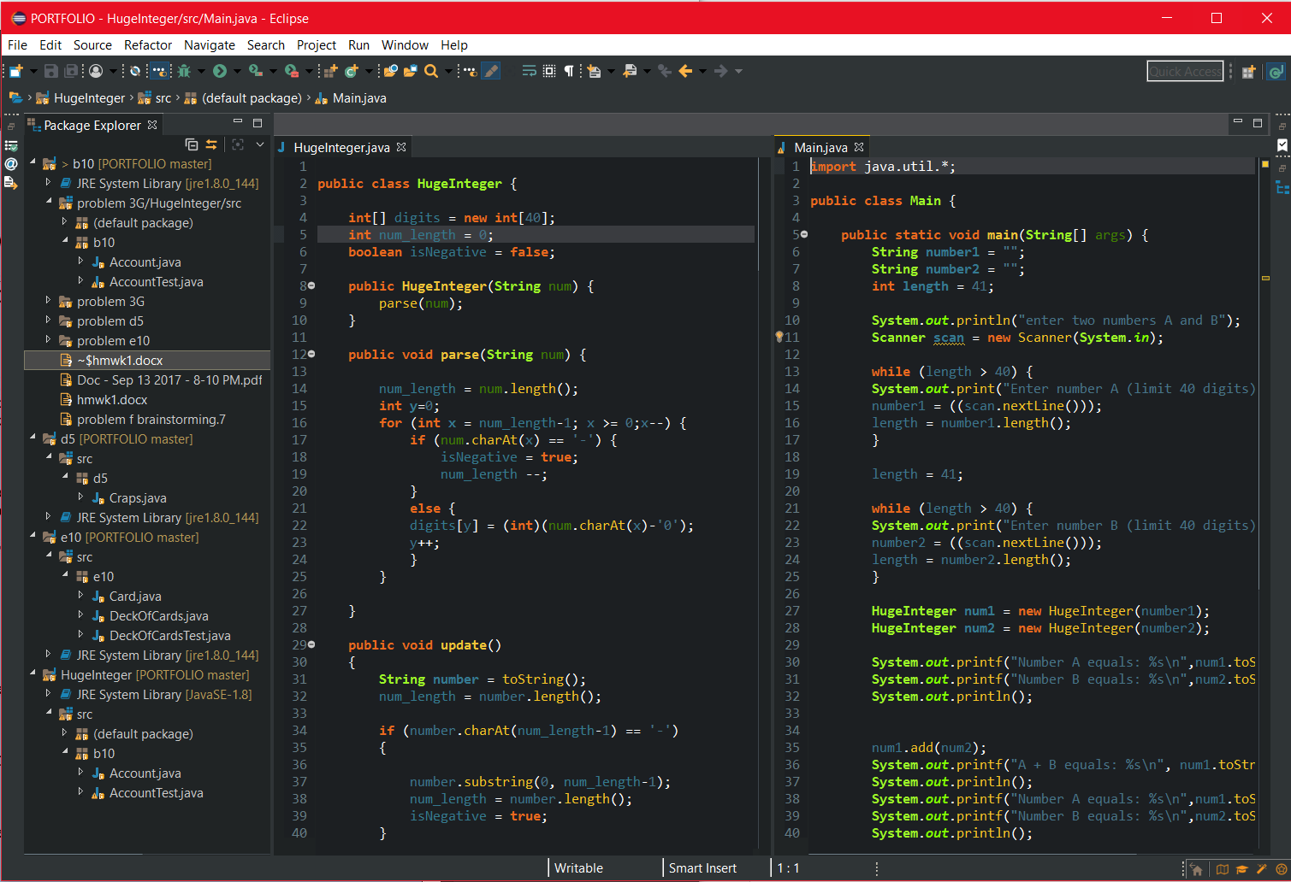

DOS: Run command Prompt, go to the directory with the program, Set JDK to use system installed java, Compile with javac <program name> , execute program with java <program name>.

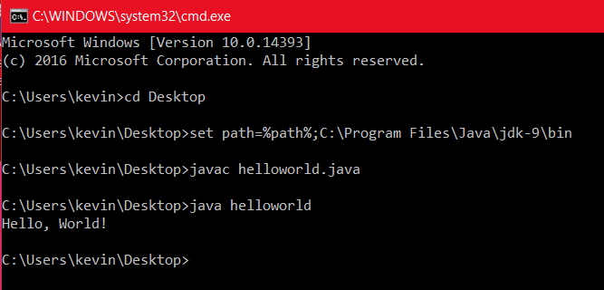

3. Programs code attached in order.

B.10

This code makes a class account with a getbalance method, which returns balance, and credit method, which adds an amount to balance. Accounts are initialized with a balance. When you first make an account the balance cannot be negative.

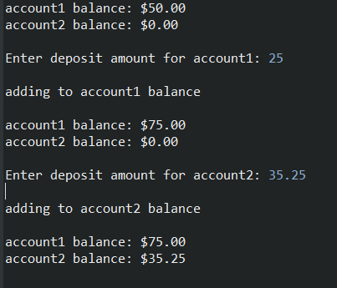

D.5

This code simulates the game of Craps. It has a roll method which rolls two dice. If the sum equal 2, 3 ,12 the player loses. If the player rolls 7, 12 the player wins. Any other number a second round starts. The player runs until the sum equals the number rolled. If a 7 is rolled in the second round the player loses.

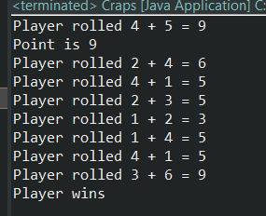

E.10

This code has a card class which has a suirt and card face. Then theres an deck object which stores 52 cards. And shuffles them. Card class has a to string method. Deck of Cards had shuffle, and dealcard.

